
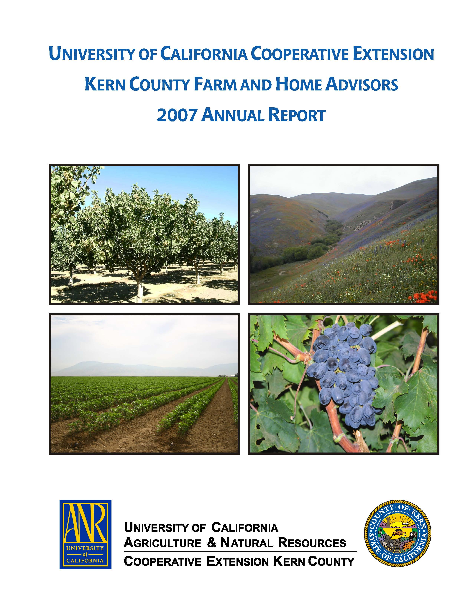
University of California Cooperative Extension – Kern County
NEWS RELEASE
1031 S. Mt. Vernon Avenue • Bakersfield, CA 93307 • 661-868-6200 • http://cekern.ucdavis.edu

January 26, 2009 Craig Kallsen, Farm Advisor

Citrus, Subtropical Horticulture, Pistachios
(661) 868-6221
Planting Navel Orange Trees: How Close Is Too Close?

Developing scientific information on tree planting densities is not easy. Trees grow slowly and the first information from newly planted trees is not available until the trees come into bearing, often three years later with navel oranges. Growers are not inclined to establish tree-spacing trials because of complications that variable row widths have on cultural operations in the rest of the orchard. Density experiments, also, are difficult to interpret in that optimal planting density evaluated over the life of the orchard is affected by the vigor and fruit-bearing characteristics of the variety and rootstock selected, cultural practices such as irrigation and fertilization practices, soil depth and texture, pruning, weather, insect and mite pressure, and other factors. Evaluations of the benefits or costs associated with a given planting density should not be based on yield alone, but should take into account later tree removal costs, cost of pruning, relative gains or losses in harvest efficiency, insect control, and other factors. The following information (Table 1) was developed by Kenneth Hench, a former citrus farm advisor in Kern County. These results are based on data from a replicated tree-spacing experiment conducted in Kern County that consisted of Frost Nucellar navel orange trees planted on Troyer citrange rootstock in 1961.

Table 1. Tree Spacing Effects on Yield of Washington Navel Orange - Kern County 1961-1972.
 |  |  | Yield, boxes/acre (50 lbs net fruit per box)
Spacing (ft)  Tree Row |  | Trees/  Acre | 1964-65 | 65-66 | 66-67 | 67-68 | 68-69 | 69-70 | 70-71 | 71-72 | Total/  acre
11  11  15  22 | 18*  22  18*  22 | 220  180  161  90 | 265  205  168  124 | 352  265  241  135 | 528  558  509  350 | 282  301  271  236 | 651  677  644  481 | 193  295  229  221 | 84  124  81  172 | 237  298  304  283 | 2592  2723  2477  2002
*moderately hedged 1967

The data in Table 1 demonstrates results seen in earlier experiments where more closely planted trees produce a greater yield of fruit during the early years of the orchard and because of the early greater yield tend to produce more fruit over the life of the orchard. Eventually as is evident in Table 1, yields per acre for any given year tend to be more equal across densities as the total volume of leaf canopy on an acre basis becomes more similar across planting densities. Frost Nucellar navel is a very vigorous variety, and the advantage seen in the early years will tend to be short-lived compared to less vigorous varieties. For example, many of the navel varieties that produce mature fruit earlier in the season are relatively slow-growing trees, and the closer spacings will usually provide higher annual yields than the wider spacings for a longer period of time than what is evident in Table 1. In the same study that resulted in Table 1, planting density was found to be a major factor affecting fruit color and size. Orange color developed first, was more intense, and the fruit was larger in the 22 ft x 22 ft spacing compared to narrower spacings. Fruit color was delayed up to 45 days after reaching legal maturity in the closely-spaced plantings once the trees became crowded. The investigators also reported a trend toward higher sugar-acid ratios earlier in the widely spaced planting. These results suggest that for the grower desiring early maturity, a wider planting may provide a higher quality fruit for the early market, however, the grower wanting to hold navels later into the season, may find a denser planting will slow maturity somewhat and provide a better quality fruit for the late market.

⧫  

