Statewide California Agritourism from the UC Small Farm Program

Agritourism is growing all over California, as groups in many counties come together to share ideas and resources to help each other develop and promote profitable visitor-serving businesses on small and mid-size farms and ranches.

Agritourism is any enterprise on a working farm or ranch or agricultural facility operated for the enjoyment and education of visitors that brings additional income to the operator. All over California, farmers are inviting visitors to participate in a variety of activities, including:

Farm stands, U-Pick operations, Wine tasting rooms, Harvest festivals, Farm tours, Packing house tours, Winery tours, Barn dances, Farm stays, Farm camps, Classes and demonstrations, Pumpkin patches, Corn mazes, Christmas tree farms, Horseback riding, Vineyard weddings and family reunions, Hunting, Fishing, Hiking, Bird-watching, Yoga retreats, Cooking classes, Rodeos, Music festivals, Petting zoos, Habitat Improvement Projects, and many other unique activities

The UC Small Farm Program’ agritourism project is building connections throughout the state among agritourism operators, promoters, organizers, advisors, regulators and farmers and ranchers considering starting agritourism businesses. We invite you to join us in these ways:

- Promote your business: www.CalAgTour.org is an online statewide directory of agritourism operations, very popular with visitors searching for a farm or ranch to visit. Listing is free. Sign your farm or ranch up using the link at www.CalAgTour.org. You can list your events too!

- Check out the website: www.sfp.ucdavis.edu/agritourism You’ll find lots of useful tips, factsheets, articles and links, including a section about the nuts and bolts of changing county agritourism regulations (www.sfc.ucdavis.edu/agritourism/planners/)

- Get news and new ideas: AgTour Connections is an email newsletter for agritourism operators, advisors, organizers, promoters, regulators, and everyone else involved in the business of California Agritourism. Check out previous issues or subscribe by clicking the links on our website (scroll down, it’s on the right): www.sfp.ucdavis.edu/agritourism

- Join the conversation: Agtour-connect listserv, hosted by UC Davis, is a discussion group for everyone involved in California agritourism. This list is for posting thoughts, events, questions, solutions, news or updates to other list members. Sign up on the website: www.sfp.ucdavis.edu/agritourism

Thanks very much for being part of developing California agritourism. I hope you find some of these resources helpful, and I’d love to hear from you about how you’re doing and what’s new in your agritourism business or your organization.
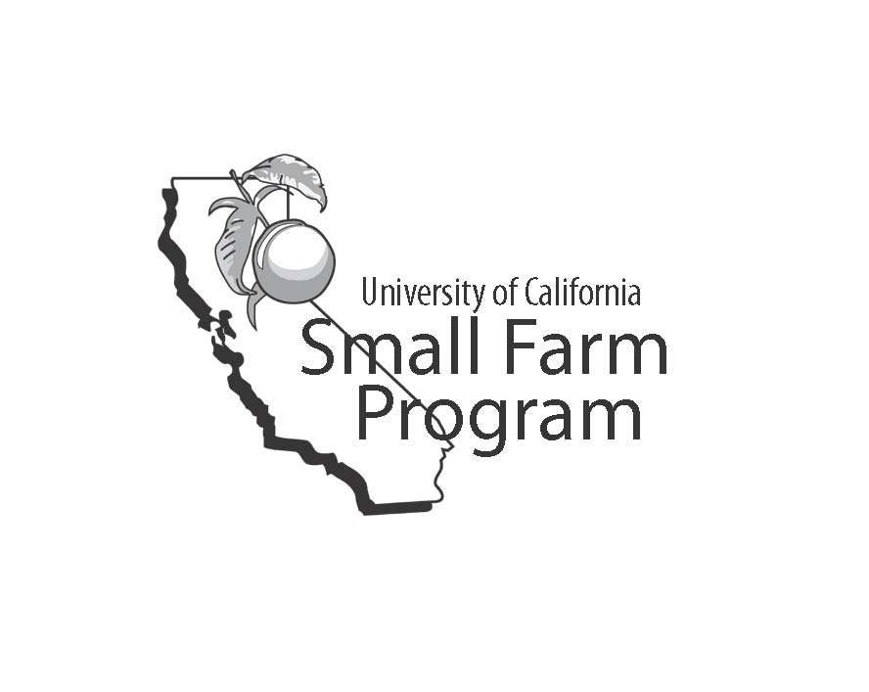
Penny

Penny Leff
Agritourism Coordinator
Small Farm Program
University of California
Davis, CA 95616
530.752.7779
paleff@ucdavis.edu

