Agritourism - suggested reading and resources
Here are links to a variety of reports, presentations, guides and an online class involving agritourism. These materials can give you an understanding of some of the opportunities and challenges facing agritourism operators, some tools for planning and starting a new enterprise, as well as some resources for those working with farmers and ranchers as they develop and promote their agritourism operations.
Presentation: Survey of California Agritourism Operators (Holly George, Ellie Rilla, Penny Leff, June 2009)
http://sfp.ucdavis.edu/agritourism/survey09.pdf

Presentation: Mitigating Risk in Agritourism Enterprises (Thilmany, Sullins and Phillips 2009)
http://www.sfp.ucdavis.edu/events/11agritourism/MitigatingRisk.pdf

Report: Regional Agricultural Marketing: A Review of Programs in California, (Derden-Little, Feenstra 2006)
http://www.sfp.ucdavis.edu/events/11agritourism/regionalmarketing.pdf

Guide: Organizing a Successful Agricultural Direct Marketing Workshop (David Chaney, et al., 2003)
http://www.sfp.ucdavis.edu/events/11agritourism/regionalmarketing.pdf

UC Issues Brief: Obstacles in the Agritourism Regulatory Process (Diana Keith, et al., 2003)
http://aic.ucdavis.edu/pub/briefs/brief22.pdf

Guide: Agritourism enterprises on your farm or ranch: Where to start (Holly George, Ellie Rilla, 2008)
http://anrcatalog.ucdavis.edu/pdf/8334.pdf
This publication gives you a game plan for navigating the maze of permits, plans, and approvals you will need to get in order before you launch a potentially profitable agritourism enterprise on your California farm or ranch. Length: 6 pp.

Guide: Agritourism enterprises on your farm or ranch: Understanding regulations (H. George, E. Rilla, 2008)
http://anrcatalog.ucdavis.edu/pdf/8333.pdf
Agritourism can be a great boon to the California grower, but you have to be aware of your legal responsibilities, get your permits, and follow the rules regarding land use, zoning, public health, and other areas. This gives you a brief overview. Length: 8 pp

Guide: Marketing Strategies for Agritourism Operations (Holly George, Ellie Rilla, 2011)
http://anrcatalog.ucdavis.edu/pdf/8444.pdf
Agritourism gives the farmer a broad choice of opportunities to market products, on-farm experiences, and hospitality services. This publication will help you assess your options and work out a solid plan for marketing your agritourism operation. Length: 21 pp.

Free online course (you will be asked to register): SARE Strategic Farm/Ranch Planning and Marketing
http://campus.extension.org/course/category.php?id=31
Strategic Farm/Ranch Business Planning and Marketing is a self-directed course designed to help agricultural professionals work effectively with their clients and develop research and education programs that address agricultural sustainability.

Resource Evaluation Guide (you will be asked to register): Taking the First Step: Farm and Ranch Alternative Enterprise and Agritourism Resource Evaluation Guide (USDA Natural Resources Conservation Service)
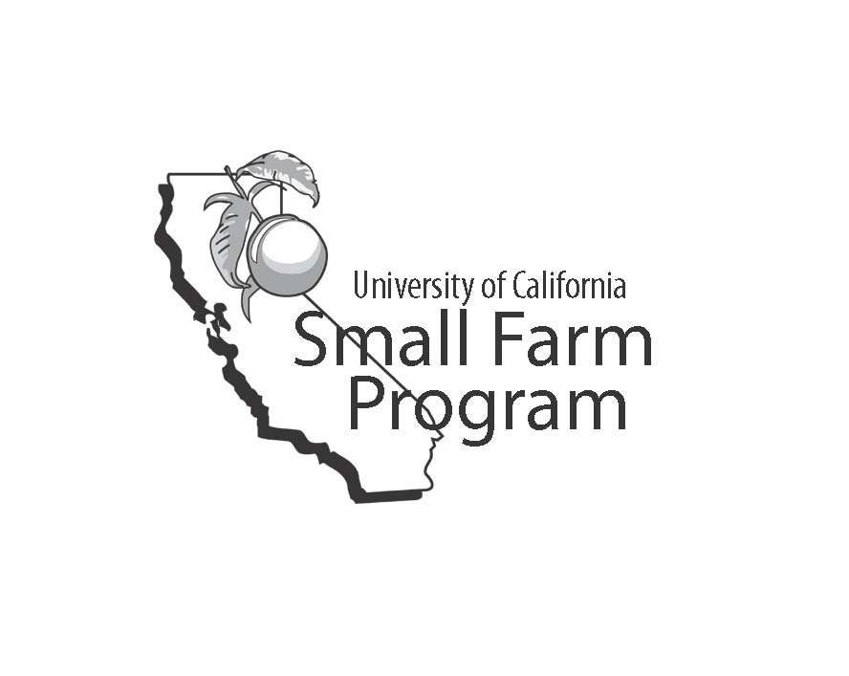
http://resourcesfirstfounTakdation.org/aea/

