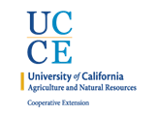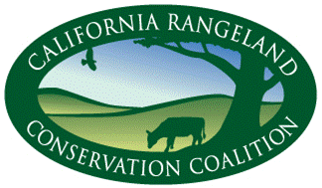

**9th Annual CA Rangeland Coalition Conservation Summit**

Evaluation Summary (85 responses)

|  |  |
| --- | --- |
| **Affiliation** | |
| Rancher | 27 |
| Landowner | 21 |
| Government | 20 |
| Environmental | 13 |
| Land Manager | 11 |
| Other | 11 |
| Agency Staff | 8 |
| Academic | 7 |
| Student | 4 |
| Land Trust | 3 |
| Foundation | 2 |
| Business | 1 |

**Acres managed (33 responses):**

815,342 (day to day)/ 7,560,400 (directly/ indirectly)

Reasons: I understand the reasons leading to loss of rangelands.

Scope: I am aware of the scope of rangeland conversion.

Alt uses: I am aware of the alternative uses of rangeland leading to conversion.

Impacts: I understand the impacts to food production, rural communities, habitat, and water resources from conversion.

2.0 = Slight, 3.0= Moderate, 4.0= Fully

**Rating of Meeting Aspects (5 is best)**

**Topics to cover in Future Summits**