**Advocacy…a brief review**

**What is it?**

Advocacy is communicating the value and need of the work that we do for our constituents, our local communities, California, the nation and even the world.

**Why is it important?**

* **Because what you do is critically important –** Your programs make a difference in the lives of people every day. If we keep this our special secret, just between them and us, why would we receive precious dollars in necessary funding to continue our work?

Without your help; the people you serve often don’t have a huge voice of their own. They need you to elevate their voices so that they can have a chance at a successful future.

* **We’re not the only game in town –** You add value to the community, but the reality is. So do many other service providers. Sometimes we may be competing for funding against public safety, after-school programs, teachers, support for the elderly, healthcare, etc. If they don’t know who we are or what we are doing for their community, why would they fund our work?

**HOW?**

1. **Be a resource…**

Most of you may already be doing this and you didn’t even know it was advocacy, but being a resource to local stakeholders is important. It establishes your credentials and shows that you’re part of the community, engaged and willing to help. You have research-based facts on nutrition education that school districts, cities and counties need in order to make sure they are doing the best they can to take care of their community. Offer your help and assistance so that the dollars that they do have, are being spent in the most helpful way possible.

1. **You’re invited…**

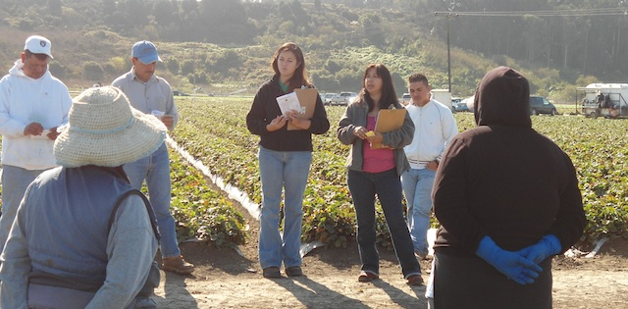While you don’t want to invite people to every single event that’s going on, make sure that at least several times a year you invite your local elected leaders and school officials to an event. In particular, get to know their staffs and invite them as well. Show them what you do and give them the opportunity to meet and interact with the people you serve.

1. 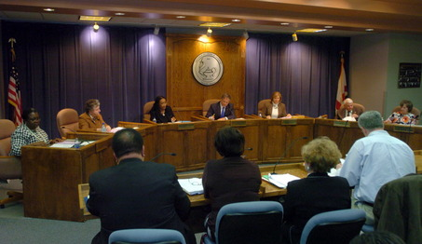**Go to the mountain…**

We can’t always expect people to come to us; sometimes we need to go to them. But don’t go alone. Bring your students and your parents – remember, it’s not really about you -- it’s about the people benefiting from your programs.

Give them opportunities to share their stories.

**What do you say?**

* This is about the people in YOUR community. What are the problems that THEY have that YOUR’RE trying to help them solve?
* All politics is local. If you’re talking to a supervisor, provide facts and issues from HER District. If you’re talking to a Mayor, talk about HIS city. If you’re talking to a Principal, tell her about HER parents and HER students. It’s about THEM.