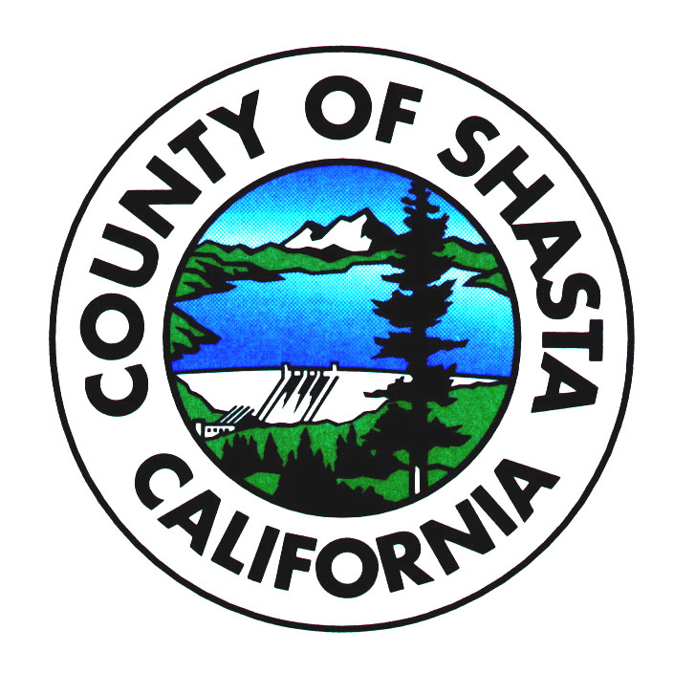
Shasta County Department of Resource Management
Environmental Health Division
1855 Placer Street, Suite 201, Redding, CA 96001
Phone: 530/225-5787 ● Fax: 530/225-5413
www.co.shasta.ca.us

CALIFORNIA HOMEMADE FOOD ACT
FREQUENTLY ASKED QUESTIONS
AB 1616 (GATTO) – COTTAGE FOOD OPERATIONS
1. When did the new law go into effect?
The new law became effective January 1, 2013. The law requires the California Department of Public Health to carry out certain tasks associated with implementation, and imposes certain responsibilities on local planning and environmental health jurisdictions. The California Conference of Directors of Environmental Health (CCDEH) is working with other stakeholders to ensure that the law is implemented in an orderly and effective manner.
2. What is a Cottage Food Operation (CFO)?
A CFO is an enterprise at a private home where low-risk food products are prepared or packaged for sale to consumers. (See #6 for a list of approved low-risk foods.)
3. What is meant by “private home?”
“Private home” means a dwelling, including an apartment or other leased space, where individuals reside.
4. Are there limitations on the size of CFO’s sales?

  - • $50,000 or less in gross sales in annually
5. Can a CFO have employees?
A CFO can have one full-time equivalent employee (not counting family members or household members).
6. What are the two classifications of CFOs?
- Class A CFO’s are only allowed to engage in “direct sale” of cottage food.
- Class B CFO’s may engage in both “direct sale” and “indirect sale” of cottage food.
7. What cottage food categories are permitted at a CFO?
Only foods that are defined as “non-potentially hazardous” are approved for preparation by CFO’s. These are foods that do not require refrigeration to keep them safe from bacterial growth that could make people sick. The California Department of Public Health will establish and maintain a list of approved cottage food categories on their website and will establish a process by which new foods can be added to the list and other foods can be challenged and removed. The initial list cited in the new law includes:
- 1) Baked goods without cream, custard, or meat fillings, such as breads, biscuits, churros, cookies, pastries, and tortillas
- 2) Candy, such as brittle and toffee
- 3) Chocolate-covered nonperishable foods, such as nuts and dried fruit
- 4) Dried fruit
- 5) Dried pasta
- 6) Dry baking mixes
- 7) Fruit pies, fruit empanadas, and fruit tamales
- 8) Granola, cereals, and trail mixes
- 9) Herb blends and dried mole paste
- 10) Honey and sweet sorghum syrup
- 11) Jams, jellies, preserves, and fruit butter that comply with the standard described in Part 150 of Title 21 of the Code of Federal Regulations. *See Below
- 12) Nut mixes and nut butters
- 13) Popcorn
- 14) Vinegar and mustard
- 15) Roasted coffee and dried tea
- 16) Waffle cones and pizzelles
- 17) Cotton Candy
- 18) Candied apples
- 19) Confections such as salted caramel, fudge, marshmallow bars, chocolate covered marshmallow, nuts, and hard candy, or any combination thereof.
- 20) Buttercream frosting, buttercream icing, buttercream fondant, and gum paste that do not contain eggs, cream, or cream cheese.
- 21) Dried or Dehydrated vegetables
- 22) Dried vegetarian-based soup mixes
- 23) Vegetable and potato chips
- 24) Ground chocolate
- 25) Season salt
- 26) Flat icing
- 27)Marshmallows that do not contain eggs
- 28) Popcorn balls
- 29) Dried grain mixes
- 30) Fried or baked donuts or waffles

*Jams, jellies, preserves, and fruit butter: Cottage food operations which produce jams, jellies, preserves, and other related products must be sure that their products meet the legal established standards of identity requirements for those products as set forth in 21 CR Part 150. The purpose of the regulation is to maintain the integrity of the food product to ensure consumers consistently get what they expect. The product name and ingredients listed on the label must be factual ad comply with the legal definitions and standards of identity or the product may be considered misbranded. Products made with other ingredients that are not defined in 21 CFR 150 cannot be produced by cottage food operations. Addition of other ingredients or alteration of ingredient profiles changes the chemistry of the food, which can allow the growth of various bacteria and toxins under the right conditions. For example, addition of peppers (i.e. jalapeno pepper) to make pepper jelly in not supported by 21 CFR 150 and the addition of this low acid ingredient could cause the formation of botulism toxin in the product if the proper controls are not used.
8. What is meant by “Direct Sale” of cottage food?
“Direct Sale” means a transaction between a CFO operator and a consumer, where the consumer purchases the cottage food product directly from the CFO. Direct sales include, but are not limited to, transactions at holiday bazaars or other temporary events, such as bake sales or food swaps, transactions at farm stands, certified farmers’ markets, or through community-supported agriculture subscriptions, and transactions occurring in person in the cottage food operation.
Note: Providing food at a temporary community event will also require a Temporary Food Facility Permit to Operate. See link below.
http://www.co.shasta.ca.us/index/drm_index/eh_index/ehd_programs.aspx
9. What is meant by “Indirect Sale” of cottage food?

“Indirect Sale” means an interaction between a CFO, a third-party retailer, and a consumer, where the consumer purchases cottage food products made by the CFO from a third-party retailer that holds a valid permit issued by the local environmental health agency in their jurisdiction. Indirect sales include, but are not limited to, sales made to retail shops or to retail food facilities where food may be immediately consumed on the premises.

10. What are limitations on Internet sales and delivery of cottage food products?

A cottage food operator may advertise as well accept orders and payments via Internet or phone. However, a CFO must deliver, in person, to the customer. A CFO may not deliver any CFO products via US Mail, UPS, FedEx or using any other third-party delivery service. A cottage food operator may not introduce a CFO product into interstate commerce.

11. What are limitations on advertising of CFO products?
It is unlawful for any person to disseminate any false advertising of any food. An advertisement is false if it is false or misleading in any particular. A cottage food product that is found to be falsely advertised would be subject to enforcement action.
12. Do I need any special Training or Certification to prepare Cottage foods?

AB 1616 requires that any person who prepares or packages cottage food complete a food processor course within three months of becoming registered or permitted. The California Department of Public Health (CDPH) does not currently have training courses available for this subject matter, and given the urgency for operators to complete the training within three months of becoming registered or permitted, CDPH has identified training that you may take that will satisfy the training requirement specified in California Health and Safety Code section 114365.2(d).

Cottage food operators (CFOs), their employee, and any household member that is involved in the preparation or packaging of cottage foods may take one of the American National Standards Institute (ANSI) accredited food handler courses that are currently required for retail food facility food handlers. The courses are available on-line or via a classroom in a variety of languages for a minimal cost. After successfully completing the course, you will receive a food handler card or certificate, which you need to retain as proof that you completed the required training. You must present a copy of this card or certificate for each person involved in preparing cottage foods to your local enforcement agency upon their request, to verify that the training requirement has been completed. Since CFOs and their employees only need take the training one time, the future expiration date on the card will not be considered when determining compliance with this requirement.

You can access a list of available food-handler training courses at the following website:
https://www.ansica.org/wwwversion2/outside/ALLdirectoryListing.asp?menuID=212&prgID=228&
13. Does a CFO need a permit to operate?
Environmental Health
For “Class A” CFO’s (direct sale only), a registration with the local environmental health agency is required.
For “Class B” CFO’s (direct and indirect), a permit from the local environmental health agency is required.
Registrations and permits are not transferable between:
- • Persons
- • Locations
- • Type of food sold
- • Type of distribution

Planning/Zoning
All CFO’s need to obtain approval from their local city or county planning department. The Homemade Food Act gives planning departments several options to consider, so planning department requirements may vary between jurisdictions and may include limitations beyond those described in the California Homemade Food Act.

- • City of Redding Planning (530) 225-4020
- • City of Anderson Planning (530) 378-6636
- • City of Shasta Lake Planning (530) 275-7431
- • Shasta County Planning Division (530) 225-5532

Fictitious Business Name
If a “fictitious name” will be used in connection with the business the name must be registered with the County Clerk’s Office.

- • Shasta County Clerk (530) 225-5730

Taxes for retail sales

- • State Board of Equalization (530) 224-4729

Employees
- • Internal Revenue Service (800) 829-1040
- • State Employment Development Department (888) 745-3886
- • State Compensation Insurance Fund (530) 223-7000 or your insurance broker for Workers Compensation Insurance

Business license

- • City of Anderson (530) 378-6626
- • City of Redding (530) 225-4056
- • City of Shasta Lake (530) 225-7431
- • Shasta County (Not Required)
14. How much will the registration or permit cost the CFO?
Class A Operations – Registration $84.24 (Annual)
Class B Operations – Permit/Inspection $168.48 (Annual)

Additional fees may be charged for inspection and/or enforcement activities if the cottage food operation is found to be in violation of applicable regulatory requirements. Also, other permit fees may apply from other agencies in order to operate.

- Will there be an additional charge to have new recipes/labels approved once my permit/registration has been issued?

Yes, there is a charge of $65.66 per hour (rounded to nearest quarter hour) for review and approval of new recipes/labels.
16. Will my CFO Registration/Permit allow me to sell at other retail venues?
There may be agricultural certifications and event permits required to sell at other locations, such as Certified Farmer’s Markets or public events. You will need a temporary or mobile permit to sell products at other public event locations as well as fairs or farmers markets.
17. How often will a CFO be inspected?
- Class A CFO kitchens and food storage areas, referenced in the law as the “registered or permitted area,” are not subject to initial or routine inspections.
- Class B CFO kitchens and food storage areas are inspected initially during to permit application review, and then annually thereafter.
- Class A and B (Other Inspections) Shasta County Environmental Health Division or Code Enforcement staff may access, for inspection purposes, the registered or permitted area where a cottage food operation is located only if the representative has, on the basis of a consumer complaint, reason to suspect that adulterated or otherwise unsafe food has been produced by the cottage food operation or that the cottage food operation is found to be in violation of applicable regulations.
18. What are the CFO’s operational requirements
  - □ All CFOs must comply with the following:
    - • No domestic activity in kitchen during cottage food preparation
  - • No infants, small children, or pets in kitchen during cottage food preparation
  - • Kitchen equipment and utensils shall be kept clean and in good repair
  - • All food contact surfaces, equipment, and utensils shall be washed, rinsed, and sanitized before each use
  - • All food preparation and storage areas shall be free of rodents and insects
  - • No smoking in kitchen area during preparation or processing of cottage food
  - • A person with a contagious illness shall refrain from working
  - • Proper hand-washing shall be completed prior to any food preparation or packaging
  - • Water used in the preparation of cottage food products must be potable (drinking quality without contamination). Cottage food preparation activities include:
    - o Washing, rinsing, and sanitizing of any equipment used in food preparation.
  - o Washing and sanitizing hands and arms.
  - o Water used as an ingredient of cottage food.
19. What would be my food labeling requirements?
All cottage food products must be properly labeled in compliance with the Federal, Food, Drug, and Cosmetic Act (21 U.S.C. Sec. 343 et seq.). The label must include:
o The words “Made in a Home Kitchen” in 12-point type.
o The name commonly used to describe the food product.
o The name, city, state, and zip code of the cottage food operation which produced the cottage food product. If the CFO is not listed in a current telephone directory, then a street address must also be declared. (A contact phone number or email address is optional but may be helpful for consumers to contact your business.)
o The registration or permit number of the CFO which produced the cottage food product and, the name of the county where the permit was issued.
o The ingredients of the food product, in descending order of predominance by weight, if the product contains two or more ingredients.
o The net quantity (count, weight, or volume) of the food product, it must be stated in both English (pound) units and metric units (grams).
o If two labels are used, all information except ingredients and allergens must be on the primary label.
o A declaration on the label in plain language if the food contains any of the eight major food allergens such as milk, eggs, fish, shellfish, tree nuts, wheat, peanuts, and soybeans. There are two approved methods prescribed by federal law for declaring the food sources of allergens in packaged foods: 1) in a separate summary statement immediately following or adjacent to the ingredient list, or 2) within the ingredient list.
o The use of the following eleven terms are considered nutrient content claims (nutritional value of a food): free, low, reduced, fewer, high, less, more, lean, extra lean, good source, and light. Specific requirements have been established for the use of these terms. Please refer to the Cottage Food Labeling Guideline for more details.
o A health claim is a statement or message on the label that describes the relationship between a food component and a disease or health-related condition (e.g., sodium and hypertension, calcium and osteoporosis). Please refer to the Cottage Food Labeling Guideline for more details.
o If the label makes approved nutrient content claims or health claims, the label must contain a “Nutrition Facts” statement on the information panel.
o Labels must be legible and in English (accurately translated information in another language may also be included on the label). Labels, wrappers, inks, adhesives, paper, and packaging materials that come into contact with the cottage food product by touching the product or penetrating the packaging must be food-grade (safe for food contact) and not contaminate the food.

In a permitted retail food facility (such as a restaurant, market, or deli), cottage food products served without packaging or labeling shall be identified to the customer as homemade on the menu, menu board or in another easily accessible location that would reasonably inform the consumer that the food or an ingredient in the food has been made in a private home.

For more information on labeling:
http://www.co.shasta.ca.us/Resource_Management/ehd_docs/CFO_label1.sflb.ashx
20. What is my legal responsibility as a Cottage Food Operator in ensuring that my food product is safe?
Cottage food operators and/or their employees shall not commit any act that may cause contamination or adulteration of food. This would include making foods that are not on the approved food list and or making foods under unsanitary conditions or with spoiled or rancid ingredients. A cottage food operation that is not in compliance with the requirements of AB 1616 would be subject to enforcement action taken by the local environmental health agency and/or the California Department of Public Health.

21. What is my liability as a cottage food business operating out of my home?

You should check with your homeowner insurance company or your landlord if you are operating out of a rental property. Many homeowner insurance policies will not extend liability coverage to liabilities arising out of home-based businesses.

Note: The information in the FAQ is intended to provide a uniform statewide response to questions posed and will be updated as needed. The questions and answers were evaluated by the CCDEH Ad Hoc AB 1616 Implementation Workgroup and deemed to reflect an understanding of the law.
AB 1616 Chaptered Law:
http://www.leginfo.ca.gov/pub/11-12/bill/asm/ab_1601-1650/ab_1616_bill_20120921_chaptered.pdf

Please see the California Department of Public Health’s website for additional information.
http://www.cdph.ca.gov/programs/Pages/fdbCottageFood.aspx

