
California 4-H Report for
Primary Members
Manual & Forms
(Ages 5 to 8)



Compatible with iSprout Curriculum

Table of Contents

Introduction 2
Definition of a 4-H Primary Member 2
Purpose of the 4-H Primary Member Program 2

iSprout 2
Yearly Requirements 2
Reflection, Incentives and Recognition 2
How to Use the Clover 2
iSprout Pins 2

Primary Member Portfolio 2

Section 1: KNOWING ME 2

Section 2: KNOWING MY FAMILY 2

Section 3: KNOWING 4-H 2

Section 4: KNOWING MY COMMUNITY 2

California State 4-H Office- 2801 Second Street Davis, CA 95618-7774 ca4h@ucanr.edu
Copyright © 2015 The Regents of the University of California.

It is the policy of the University of California (UC) and the UC Division of Agriculture & Natural Resources not to engage in discrimination against or harassment of any person in any of its programs or activities (Complete nondiscrimination policy statement can be found at http://ucanr.edu/sites/anrstaff/files/215244.pdf ) Inquiries regarding ANR’s nondiscrimination policies may be directed to John I. Sims, Affirmative Action Compliance Officer/Title IX Officer, University of California, Agriculture and Natural Resources, 2801 Second Street, Davis, CA 95618, (530) 750- 1397.

Introduction

Definition of a 4-H Primary Member
Primary members are youth between the ages of 5 and 8, enrolled in the 4-H program. Primary members must be 5 years old by December 31st of the program year and not older than 8 years old by December 31st of the program year. Youth who turn 9 on or after January 1st must participate as a primary member until June 30th of the program year.

Primary aged youth are impressionable and respond well to exciting and creative activities. This is a critical stage in the development of the young child and an excellent time to enhance a child’s learning experiences in self-perception.

Researchers estimate that children experience 50% of their learning before 4 years of age, another 30% before the age of 8. Therefore, it is important to offer non-formal, exploratory programs that focus on the developmental needs of younger children.

Purpose of the 4-H Primary Member Program
The purpose of the 4-H Primary Member Program is to assist youth in becoming capable, competent, caring and contributing citizens. Keep in mind that:
- Adult volunteers should provide open-ended activities that promote skills practice.
- Activities should focus on the process of doing things rather than the finished product.
- Activities should make use of participants' experience and encourage exploration, rather than written or verbal lessons.
- Participation for primary members should be limited to cooperative learning activities with no competition.

The California 4-H Youth Development Program (YDP) has specific policies for all of its programs, events and activities. Some policies are specifically related to primary aged members and activities while others govern all roles and responsibilities within the 4-H YDP. Before you begin the California 4-H iSprout project, be sure that you are familiar with and follow all of the California 4-H Youth Development Program policies, found at: http://4h.ucanr.edu/Administration/Policies/. The UCCE 4-H Office staff in your county can help you with specific questions that you may have about policy implementation.

iSprout

In California, the iSprout educational materials are the recommended curriculum for primary aged youth enrolled in a Leadership/Personal Development Project; as the Primary Project; during a club meeting and primary members are pulled out of the business meeting for their own activities; during special events as primary member activities.

iSprout is designed to be very flexible and is divided into four sections, multiple topics and a plethora of activities as follows:

4 Sections – These are the major areas of the project:
- Knowing Me
- Knowing My Family
- Knowing 4-H
- Knowing My Community

Topics – Each section offers many topics. The topics cover a specific area of learning.

Activities – Each topic offers many activities to choose from. The activities offer different ways of addressing the topic. Some are more complex while others require more supplies, equipment or space.

Yearly Requirements
To complete iSprout as a project and to be eligible to earn the achievement pin, youth should complete all of the following:

Two topics from each of these sections:
2 topics from each of the 3 sections
        - Knowing Me (Start each year with “I’m Happy” page 29)
        - Knowing My Family
        - Knowing 4-H
One Service Project – includes two of the topics from “Knowing My Community”
Both of these
          - “What Needs to be Done?” (choosing and planning a project)
        - “I Helped” (project day, reflection and celebration)
One other activity in “Knowing My Community” each year.
- I Am A Citizen
1 of these
- I Add Value
- Mapping My Neighborhood
- I Have Connection
- How Do I Help

This amounts to approximately one meeting a month for 9 months. Additional field trips or additional service project meetings can always be added. Some activities do not require a whole meeting, while others may need to be done over the course a few meetings. Continuing activities from one meeting to the next allows you to gather information and/or supplies, based on plans made or family involvement as needed. Use the checklists/planning worksheets found on pages 10-11.

Reflection, Incentives and Recognition
Young children do not engage in deep self-reflection, however they can be mindful of what they learned, think and feel in the moment. Each topic has guiding prompts that are italicized in purple to help introduce the topic at the beginning of the lesson and process the lesson at the end. These are things you should say or ask. Young children will only discuss and process for about 5-10 minutes. The iSprout Clover is designed to be completed at the end of each meeting to help young children start to develop mindfulness skills that will lead to self-reflection skills as they reach adolescence.

How to Use the Clover
- Make one copy for each member, per lesson, per meeting.
- After completing the “process the concept” questions, give each member a clover and have them complete the top of the form. If they are 5-6 year olds, they should be able to write their name, but may need help completing the “what I learned” portion.
- Explain to members that you are going to read a statement or question and they can draw something that answers that question in one of the petals of the clover. For example, you can say, “In the top right hand petal, draw something that….”
- Read one prompt at a time and allow children to finish that petal before moving on to the next one.
- Consider collecting the clovers at the end of each lesson and compiling them in a booklet to present to each member at the end of the project year along with their achievement pin.

Additionally, the iSprout Clover can be used as a program review tool for project leaders to see if members seemed to understand the lesson taught.

iSprout Pins
Primary members who complete the basic requirements of iSprout are eligible to receive an achievement pin each year that they participate. Pins are available in four colors—a different color for each year and can be ordered from http://4h.ucanr.edu/Resources/Members/Awards/

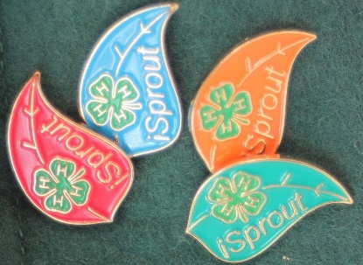

Primary Member Portfolio
This is a picture of me:

Name: ___________________________________ Program Year:_______________

4-H Club or Unit: _____________________________

County: ___________________________

Years in 4-H: ____________

Age: ____________

Address: _________________________________

City:___________________ State: ______

Zip: ________________

Phone: _(_____)_______-________

Club Meetings Attended This Year  Do not include project meetings. | Meetings Held | Meetings Attended | Hours Attended

- I made this report and I think it is correct.
Member’s Signature: | Date:
I have personally reviewed this report and believe it to be correct.
Parent/Guardian Signature: | Date:
4-H Adult Partner’s Signature: | Date:

Section 1: KNOWING ME

Choose 2 Topics from “Knowing Me”

  - I’m Happy
- Making My Best Better!
- Reaching My Goals!
- I Can Do That!
- I Rock!
- I’m Good and Honest!
- I Care!
- I’ve Got Friends!
- I Deal With My Feelings!

The two (2) “Knowing Me” topics we chose are:
1.
2.

Complete 2 activities for each topic you chose (a total of 4 activities).
The four (4) “Knowing Me” activities I did are:
 | Topic 1: | Topic 2:
Activity 1
Activity 2

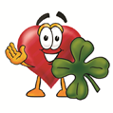
Place the “My _____ Clover” pages you completed for this section to the back of this page.

Section 2: KNOWING MY FAMILY

Choose 2 Topics from “Knowing My Family”

  - Happy Family!
  - I Help At Home!
  - Good Manners Start At Home!

The two (2) “Knowing My Family” topics we chose are:
1.
2.

Complete 2 activities for each topic you chose (a total of 4 activities).
The four (4) “Knowing My Family” activities I did are:
 | Topic 1: | Topic 2:
Activity 1
Activity 2

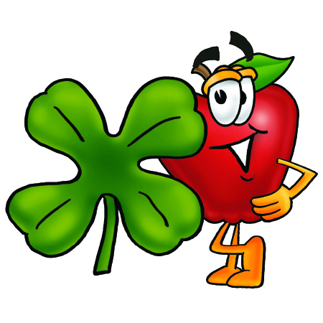
Place the “My _____ Clover” pages you completed for this section to the back of this page.

Section 3: KNOWING 4-H

Choose 2 Topics from “Knowing 4-H”

- SCIENCE, ENGINEERING, AND TECHNOLOGY

  - Raising Animals
  - Earth Science
  - Outdoor Adventure
  - Gardening
  - Robots
  - Rocketry
  - Woodworking
  - Bicycling
  - Photography
  - Computers
  - Electronic Tools and Games

- HEALTHY LIVING

  - I Know What’s Healthy to Eat!
  - I’ve Got the Moves!
  - Health
  - Arts and Crafts
  - Music
  - Recreation

The two (2) “Knowing 4-H” topics we chose are:
1.
2.

Complete 2 activities for each topic you chose (a total of 4 activities).
The four (4) “Knowing 4-H” activities I did are:
 | Topic 1: | Topic 2:
Activity 1
Activity 2


Place the “My _____ Clover” pages you completed for this section to the back of this page.

Section 4: KNOWING MY COMMUNITY

Choose 1 Topic from “Knowing My Community”

- I Am A Citizen
- Ideas Matter!
- Mapping My Neighborhood
- I Have Connection
- How Do I Help?

The “Knowing My Community” topic we chose is:

Complete one (1) activity for the topic you chose.
The “Knowing My Community” activity I completed is:

Choose, Plan, and Implement a Service Project.

What Needs to Be Done?
My project group chose a service project! This is our project outline:
Who we helped:
What we did:
When we did it
Where we did it:
Why we did this:

Project Day (Write or Draw)
What did you learn?
Was it easy or hard? What was easy or hard about it?
Did you have fun? Do you think your friends had fun too? Why?

Congrats! You made a difference!

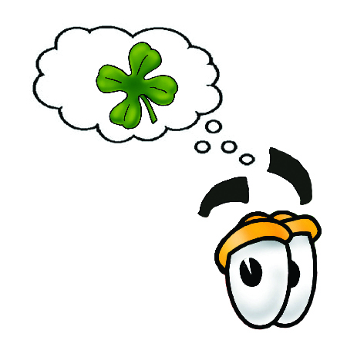
Place the “My _____ Clover” pages you completed for this section to the back of this page.

