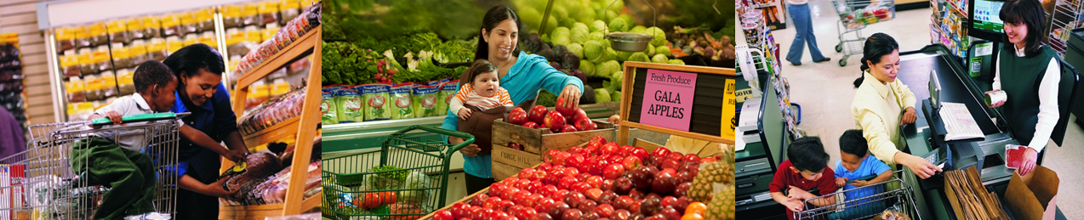

Where Can I Get More Food for My Family?

**CalFresh** – available to those who qualify

* Apply online at <https://www.getcalfresh.org/>
* You will need:
  + A copy of your ID
  + Proof of any income (such as paycheck stub or tax return)
  + Proof of immigration status (for non-citizens)

**School Meals** – **all** students can get free breakfast and lunch at school

**Summer Meals** – free meals for students during school breaks

* Find Locations <https://www.cde.ca.gov/ds/sh/sn/summersites22.asp>
* CA Meals for Kids Mobile App – free from your app store

**WIC** (CA Women, Infants and Children Program) - A nutrition program for babies, children under 5, pregnant women and new moms

* <https://myfamily.wic.ca.gov/> - click ‘How Can I Get WIC?’
* A picture containing logo

  Description automatically generatedOr you can call toll free: 1-888-WIC-WORKS (1-888-942-9675)

What do I bring to my first WIC appointment?

* Each person who will be enrolling into the WIC program
* Identification - for yourself & any children age birth to 5 years
* Proof of address - a document verifying your current address
* Proof of income - such as paycheck stub, tax return or letter from employer

**Food Bank** –

**211** – 3-digit number for information and referrals to social services and other assistance

* Finding Food <https://www.211.org/get-help/finding-food>
* Search by location: <https://www.211.org/about-us/your-local-211>