

Ventura County Garden to Table Series –

Artichoke-Tomato Tango - Recipes

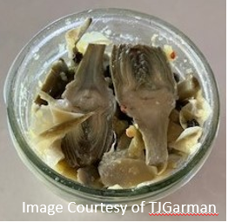
Marinated Artichoke Heart Recipe - https://ciaoflorentina.com/marinated-artichoke-hearts-recipe/#recipe.

Note: most recipes I found online are not for the home grower of artichokes – this link is one I followed. Please keep in mind that when you use fresh – from your garden – artichoke, the hearts are not a “clean” as store bought ones – and I use some of the “meat” from the artichoke leaves. So I call mine – artichoke “parts.

“Tango” Recipes – these are just a few I found online – I encourage you to explore and experiment.

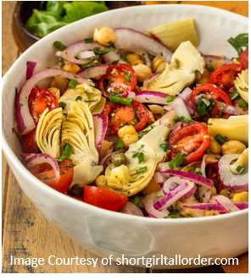
  - Tuscan Artichoke and Tomato Salad – a great summer recipe using what you grow in the garden. https://shortgirltallorder.com/artichoke-tomato-salad
  - Braised Artichokes in Tomato Sauce - This dish consists of tender artichokes braised in a spicy tomato sauce - are great served warm or at room temperature, but however you serve them, make sure that you offer some good Italian bread along. https://italianfoodforever.com/2017/05/braised-artichokes-in-tomato-sauce/
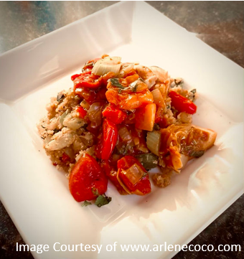
- Artichoke Tomato Stew – works well as a base for dishes using seafood, vegetables, or meatballs. https://www.arlenecoco.com/single-post/quick-and-easy-artichoke-tomato-stew
- Artichoke and Tomato Crostini - Lemony artichokes, garlic, red onion and diced tomatoes are dressed with olive oil and balsamic vinegar for a bruschetta-like topping. Served on warm, cheese and herb crostini. https://tuttorossotomatoes.com/recipes/detail/artichoke-and-tomato-crostini

Happy cooking – see you at the next class – Terry.

